# **Training Center Task Documentation**

Database Diagram

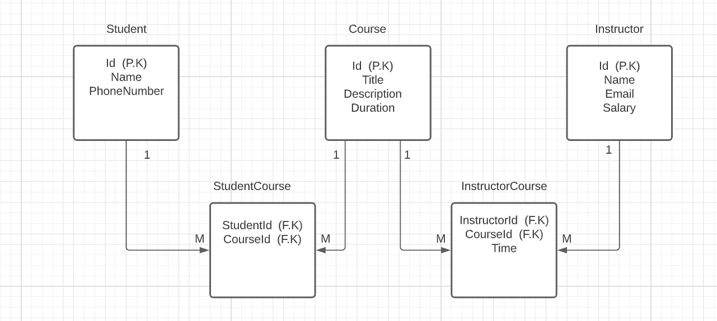

Database Relations

* Student Has Relation Many To Many With Course
* Instructor Has Relation Many To Many With Course
* Student Has Relation One To Many With StudentCourse
* Instructor Has Relation One To Many With InstructorCourse

**Note** : Data Folder Contains the Database File.

Please Change the database connection string from appsettings.json

Pages

Student

* /student/index -- get all students
* /student/create -- create new students
* /student/update -- update student
* /student/Delete -- delete student

Instructor

* / instructor /index -- get all instructor
* / instructor /create -- create new instructor
* / instructor /update -- update instructor
* / instructor /Delete -- delete instructor

Course

* /course/index -- show all course
* / course /create -- create new course
* / course /update -- update course
* / course /Delete -- delete course
* / course /AssignInstructor -- assign course instructor

InstructorCourse

* /course/index -- show report contain course title & instructor name & course date
* / course /create -- assign course to instructor